**Re-write the following words in the blank spaces 5 times each:-**

**The tenets of Taekwon-Do**

|  |
| --- |
|  |

***Note: A tenet is a belief that is held to be true.***

**Courtesy**

|  |
| --- |
|  |

**Integrity**

|  |
| --- |
|  |

**Perseverance**

|  |
| --- |
|  |

**Self-Control**

|  |
| --- |
|  |

**Indomitable Spirit**

|  |
| --- |
|  |

**Re-write the following 2 times:-**

**I shall observe the tenets of Taekwon-Do.**

|  |
| --- |
|  |

**I shall respect the instructor and seniors.**

|  |
| --- |
|  |

**I shall never misuse Taekwon-Do.**

|  |
| --- |
|  |

**I shall be a champion of freedom and justice.**

|  |
| --- |
|  |

**I shall build a more peaceful world.**

|  |
| --- |
|  |

**Name the 3 sections of the body.**

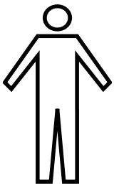

**How many lines are there on the body? (See dotted lines above)**

**_____________________________________________________**