Attacking Tools
*Source of most pictures from Volume 2 of the 15 volume Encyclopaedia. Otherwise pictures of Chen Weiling’s very crooked arms.
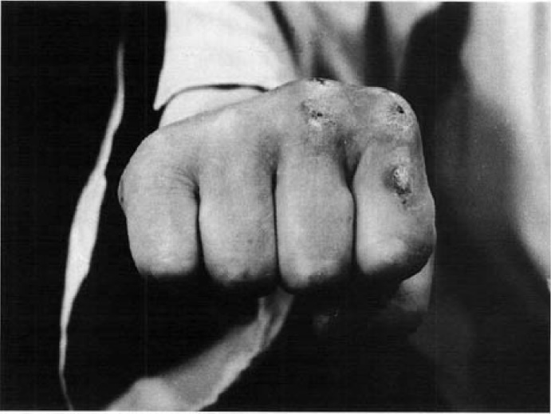  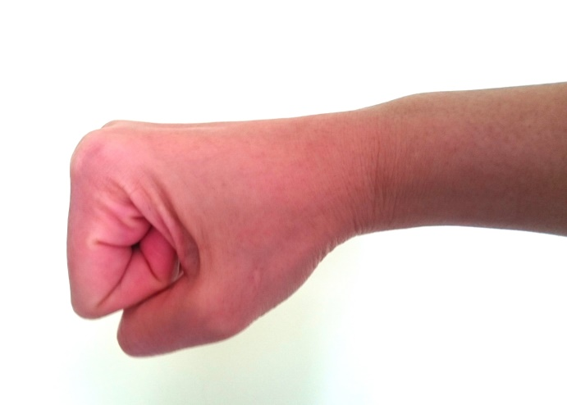  90⁰ | Ap Joomuk  The forefist is generally used for attacking the philtrum, ribs, solar plexus, chest, abdomen, jaw, etc.  The main knuckles of the forefinger and middle finger are the attacking tools.  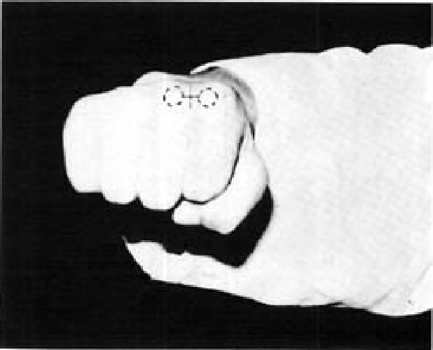  The top and front of the fist should form a right angle so the punching parts can be closely contacted with the target.  The wrist should not be bent when the fist is clenched.
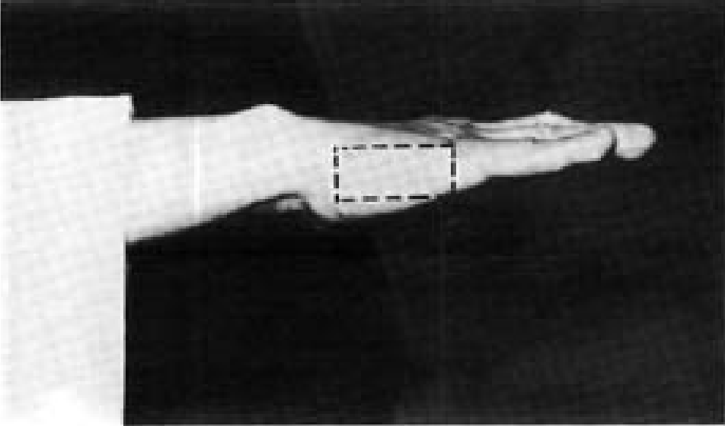  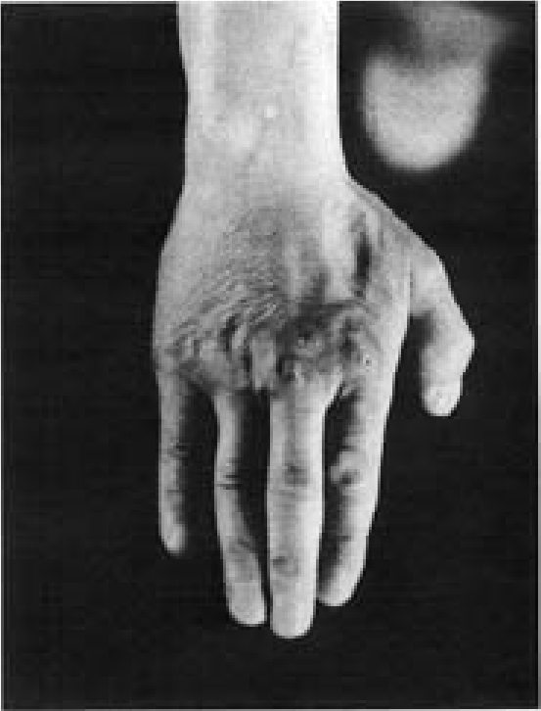 | Sonkal  The knifehand is a very powerful attacking tool, especially against a side target.  This is used for attacking the skull, neck, bridge of the nose, temple, philtrum, clavicle, shoulder, and floating ribs.  The knife hand is also used for blocking.  Press four fingers together bending the middle finger and ring finger slightly inward leaving some space between the forefinger and thumb, so that most of the strength is concentrated on the attacking tool.  The attacking tool is the surface from the wrist to the side of the knuckle of the little finger.
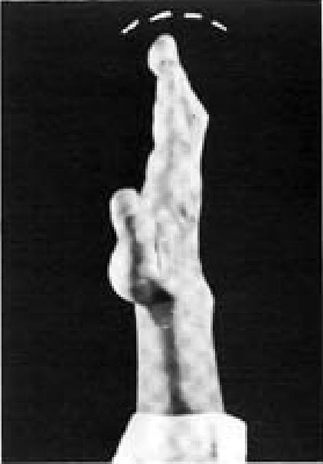 | Sonkut  The usage of _fingertip_ thrusts varies according to the target. Fingertips are the attacking tool with a great emphasis on evenly aligning the 3 fingertips – forefinger, middle finger and ring finger.
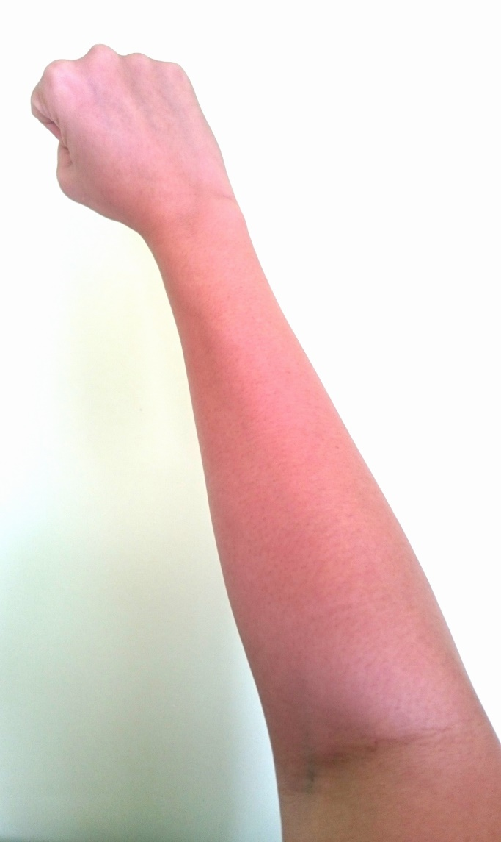  Back forearm  Inner forearm  Outer forearm | Palmok  The forearm is used for blocking and is classified into outer, inner, back and under forearm.  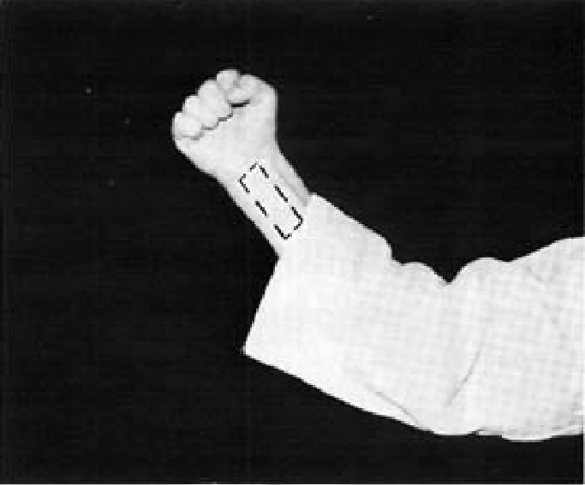  One-third of the arm, measuring from the wrist to the elbow, is used.  Under forearm
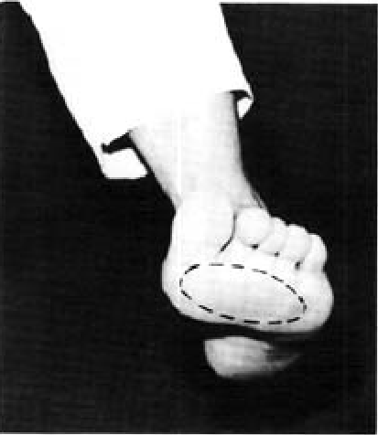 | Apkumchi  The ball of the foot is used for front snap kick and other kicks. The toes are bent sharply upwards at the moment of impact.  It is used to attack the face, point of the chin, inner thigh, chest, solar plexus, floating ribs, scrotum, coccyx and lower abdomen.
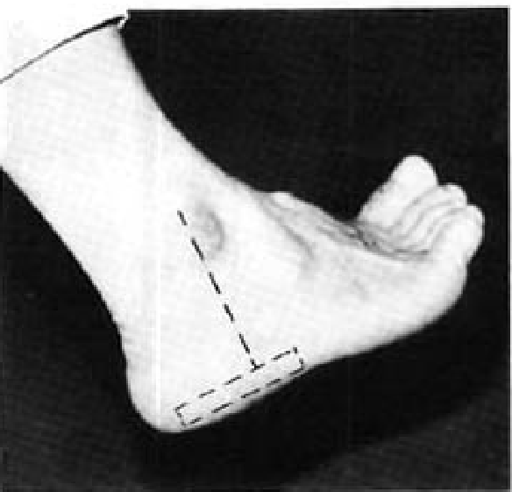 | Balkal  The footsword is considered the most important tool of the foot and is used to attack the philtrum, bridge of the nose, neck, solar plexus, chin, temple, armpit, floating ribs, knee joint, ankle joint and instep.  Frequently it is used for blocking. One-third of the edge, from the heel to the joint of the little toe, is the part used.  Remember to push out the heel while bending the toes upwards to properly tense the footsword at the moment of impact.
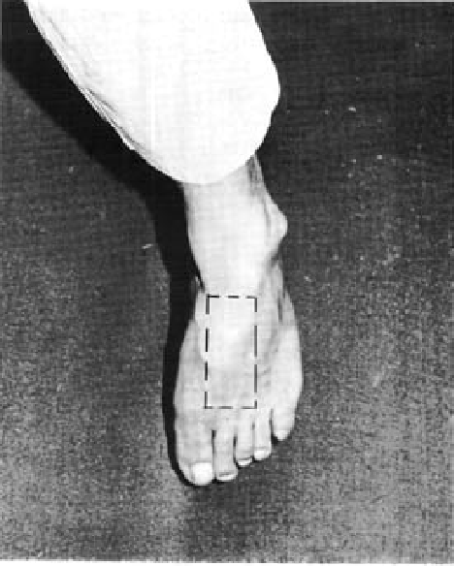 | Baldung  The instep is created when both the ankle and toes are bent sharply downward and is exclusively used in attacking the scrotum or jaw.  However, the face, solar plexus, floating ribs and abdomen often become good targets, especially if shoes are worn.

Test
- The attacking tool for a punch is _____________________.

- The attacking took for an inner forearm middle block is _____________ part of the forearm.

- The attacking tool for a knifehand is ____________________.

- The attacking tool for a front snap kick is ____________________________.

- The attacking tool for a side piercing kick is ___________________________.

- The attacking tool for a turning kick with shoes, or on a soft target is ______________________________.

- The attacking tool for a turning kick without shoes is ________________________________________.

